21. Prolog Program to Implement Towers of Hanoi
Name:P.Gayathri
Reg.No:192424324

Aim
To write and execute a Prolog program to solve the Towers of Hanoi problem using recursion and display the sequence of moves required to transfer all disks from the source peg to the destination peg.
Algorithm :
- Start the program.
- Define the base case for one disk.
- If there is only one disk, move it directly from the source peg to the destination peg.
- For more than one disk, recursively move N-1 disks from the source peg to the auxiliary peg.
- Move the remaining largest disk from the source peg to the destination peg.
- Recursively move the N-1 disks from the auxiliary peg to the destination peg.
- Display each disk movement.
- Repeat until all disks are transferred.
- Stop the program.

PROGRAM:
% Towers of Hanoi

hanoi(1, Source, Destination, _) :-
write('Move disk from '),
write(Source),
write(' to '),
write(Destination),
nl.

hanoi(N, Source, Destination, Auxiliary) :-
N > 1,
N1 is N - 1,

hanoi(N1, Source, Auxiliary, Destination),

write('Move disk from '),
write(Source),
write(' to '),
write(Destination),
nl,

hanoi(N1, Auxiliary, Destination, Source).
INPUT:
?- hanoi(3, a, c, b).

OUTPUT:
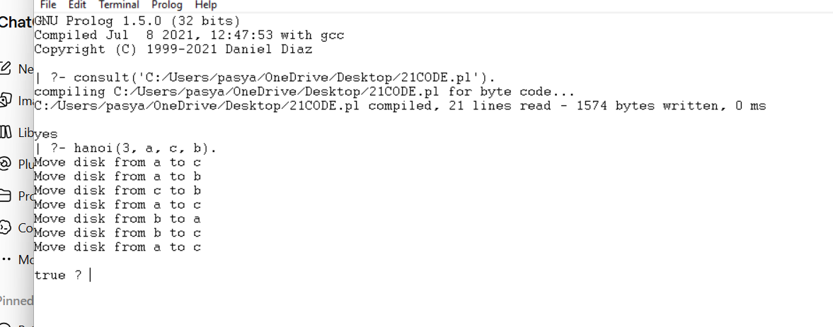

RESULT:
Thus, the Towers of Hanoi problem was successfully implemented in Prolog using recursion, and the required sequence of disk movements was obtained successfully.

